Explanation

INTERFACE OF THE MICROCONTROLLER AND GSM/GPS THROUGH MAX232 (RS232 CONECTIVITY)
Several devices collect data from sensors and need to send it to another unit, like a computer or microcontroller for further processing. So the data has to be sent from one unit to the other. Like here the data that GSM/GPS receives has to be sent to the microcontroller and also the data has to be sent from the microcontroller to the GSM/GPS for the controlling purpose. The communication between GSM/GPS to microcontroller and vice versa has to be done serially. The logic levels of the GSM/GPS (12v) and microcontroller (5v) are different hence to make the GSM/GPS and microcontroller compatible we require MAX232 compatible device.
Data transfer/communication is generally done in two ways: parallel and serial. In the parallel mode, data transfer is fast and uses more number of lines. This mode is good for short range data transfer.
Serial communication on the other hand, uses only one or two data lines to transfer data and is generally used for long distance communication. In serial communication the data is sent as one bit at a time. This article describes the interfacing of 89c51 microcontroller with a GSM/GPS via serial port, RS232. Serial communication is commonly used in applications such as industrial automation systems, scientific analysis and certain consumer products.
MAX-232 version of serial I/O standard, which is most widely used in PCs, GSM/GPS and several devices. In MAX232, high and low bits are represented by flowing voltage ranges.

Bit | Voltage Range (in V)
0 | +3 | +25
1 | -25 | -3

Therefore, while connecting a GSM/GPS to microcontroller system, a voltage converter is required. This converter converts the microcontroller output level to the GSM/GPS voltage levels, and vice versa. IC MAX232 also known as line driver is very commonly used for this purpose.

The simplest connection between a GSM/GPS and microcontroller requires a minimum of three pins, RxD (receiver, pin2), TxD (transmitter, pin3) and ground (pin5) of the serial port of GSM/GPS.

MAX232 has two sets of line drivers for transferring and receiving data. The line drivers used for transmission are called T1 and T2, where as the line drivers for receiver are designated as R1 and R2. The connection of MAX232 with computer and the controller is shown in the circuit diagram.

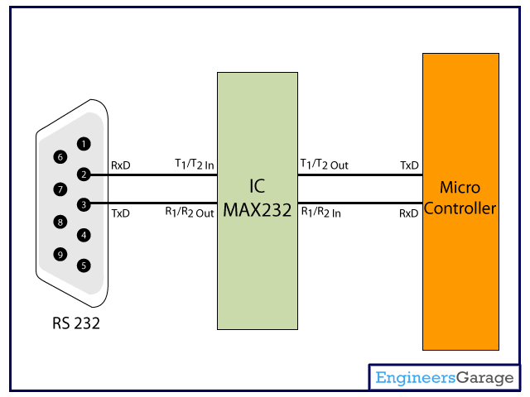
Assume rs422 as GSM/GPS module

An important parameter considered while interfacing serial port is the Baud rate which is the speed at which data is transmitted serially. It is defined as number of bits transmitted or received per second. It is generally expressed in bps (bits per second). AT89C51 microcontroller can be set to transfer and receive serial data at different baud rates using software instructions.

The MAX232 IC is used to convert the TTL/CMOS logic levels to RS232 logic levels during serial communication of microcontrollers with GSM/GPS. The controller operates at TTL logic level (0-5V) whereas the serial communication with GSM/GPS works at 12v. This makes it difficult to establish a direct link between them to communicate with each other. hence max232 IC works as voltage level converter for both the GSM/GPS and microcontroller.

The intermediate link is provided through MAX232. It is a dual driver/receiver that includes a capacitive voltage generator to supply RS232 voltage levels from a single 5V supply. Each receiver converts GSM/GPS inputs to 5V TTL/CMOS levels. The drivers (T₁ & T₂), also called transmitters, convert the TTL/CMOS input level into RS232 level.

The transmitters take input from controllers serial
Transmission pins and sends the output to GSM/GPS receiver. The receivers, on the other hand, take input from transmission pin of serial port and give serial output to microcontroller’s receiver pin. MAX232 needs four external capacitors whose value ranges from 1µF to 22µF.

Pin Diagram:
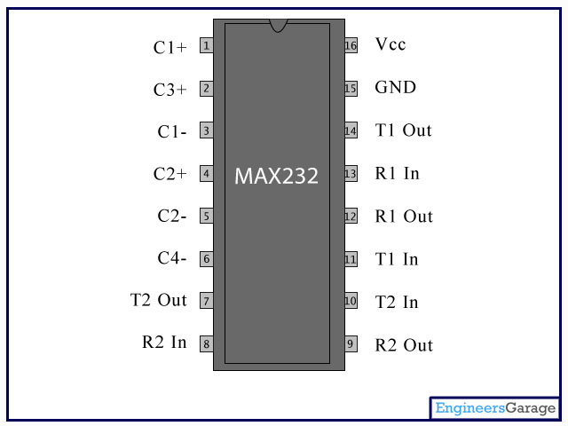
Pin Description:

The microcontroller works at 5v, the output of the microcontroller should be made compatible for GSM/GPS i.e. 12v that is done by the max232 IC. The IC max232 converts microcontroller output compatible to GSM/GPS modem and also the GSM/GPS output to the microcontroller 5v as input. The controller is programmed using AT commands to interact with GSM/GPS.
Microcontroller

communicates using AT commands

The GSM/GPS Smart Modem is a multi-functional, ready to use, rugged unit that can be embedded or plugged into any application. The Smart Modem can be controlled and customized to various levels by using the standard AT commands. The modem is fully type-approved, it can speed up the operational time with full range of Voice, Data, Fax and Short Messages (Point to Point and Cell Broadcast),

The logical level of the modem is not compatible with logical states of controller so need have logical conversion from modem to UART port of controller through MAX 232 interface. The standard voltage range on RS-232 pins is _15V to +15V. This voltage range applies to all RS-232 signal pins. The total voltage swing during signal transmission can be as large as 30V. In many cases, RS-232 ports will operate with voltages as low as _5V to +5V. This wide range of voltages allows for better compatibility between different types of equipment and allows greater noise margin to avoid interference.
Because the voltage swing on RS-232 lines is so large, the RS-232 signal lines generate a significant amount of electrical noise.

The main role of the RS232 chip is to convert the data coming for the 12-volt logic to 5 volt logic and from 5 volt logic to 12 volt logic .RS 232 CONVERTER is a chip to convert the TTL voltage levels into RS 232 level and vice versa, this chip is developed by Maxim Corporation.

